

Travlr Getaways

CS 465 Project Software Design Document
Version 1.0

Table of Contents

CS 465 Project Software Design Document 1
Table of Contents 2
Document Revision History 2
Instructions 2
Executive Summary 3
Design Constraints 3
System Architecture View 3
Component Diagram 3
Sequence Diagram 4
Class Diagram 4
API Endpoints 4
The User Interface 4

Document Revision History

Version | Date | Author | Comments
1.0 | 09/30/2026 | Anna Fuentes | Completed Milestone One sections: Executive Summary, Design Constraints, and System Architecture View.

Instructions

Fill in all bracketed information on page one (the cover page), in the Document Revision History table, and below each header. Under each header, remove the bracketed prompt and write your own paragraph response covering the indicated information.

Executive Summary

The Travlr Getaways web application will use a full stack architecture based on the MEAN stack, which consists of MongoDB, Express, Angular, and Node.js. Within this architecture, MongoDB provides data storage and retrieval, Express and Node.js support server-side application logic, and Angular provides the user interface and front-end interactions (MongoDB, n.d.). This structure allows the presentation, application logic, and data portions of Travlr Getaways to remain organized while still working together as one application.

The customer-facing portion of Travlr Getaways will allow visitors to view travel information and available trips through webpages delivered using Node.js and Express. Handlebars (HBS) templates can dynamically display trip information rather than requiring the content to remain hardcoded in individual HTML pages. The application will also include an administrator single-page application (SPA) developed with Angular. The SPA will provide administrators with a more interactive interface for managing travel information, while the public-facing site will focus on presenting that information to customers. Angular is designed for dynamic web applications and serves as the presentation layer within the MEAN architecture (MongoDB, n.d.). Both interfaces will ultimately work with the same underlying application data and server functionality.

Design Constraints

The Travlr Getaways application has several design constraints that influence how it must be developed. One major constraint is the required MEAN technology stack, which establishes MongoDB, Express, Angular and Node.js as the primary technologies used throughout the application. These technologies serve different roles within the architecture and therefore must communicate successfully across the client, application, and database layers (MongoDB, n.d.). Another constraint is the requirement to support two different interfaces: a public customer-facing website and an administrator SPA. The customer interface must make travel information easy to access, while the administrator interface must provide the additional functionality necessary to manage application data.

These constraints affect how the application is organized and developed. Separating routes, controllers, views, and data helps keep responsibilities organized as the application grows. Data must also remain structured consistently as the project transitions from mock JSON data to persistent storage in MongoDB. Because the administrator SPA and server must exchange information, the application also requires a clearly defined method for communication between the client and the server. In a MEAN client-server architecture, the Angular client communicates with the server, while Node.js and Express implement server-side functionality and MongoDB provides the data layer (MongoDB, n.d.). These constraints require careful planning but provide a consistent structure for maintaining and expanding the Travlr Getaways application.

System Architecture View

Component Diagram

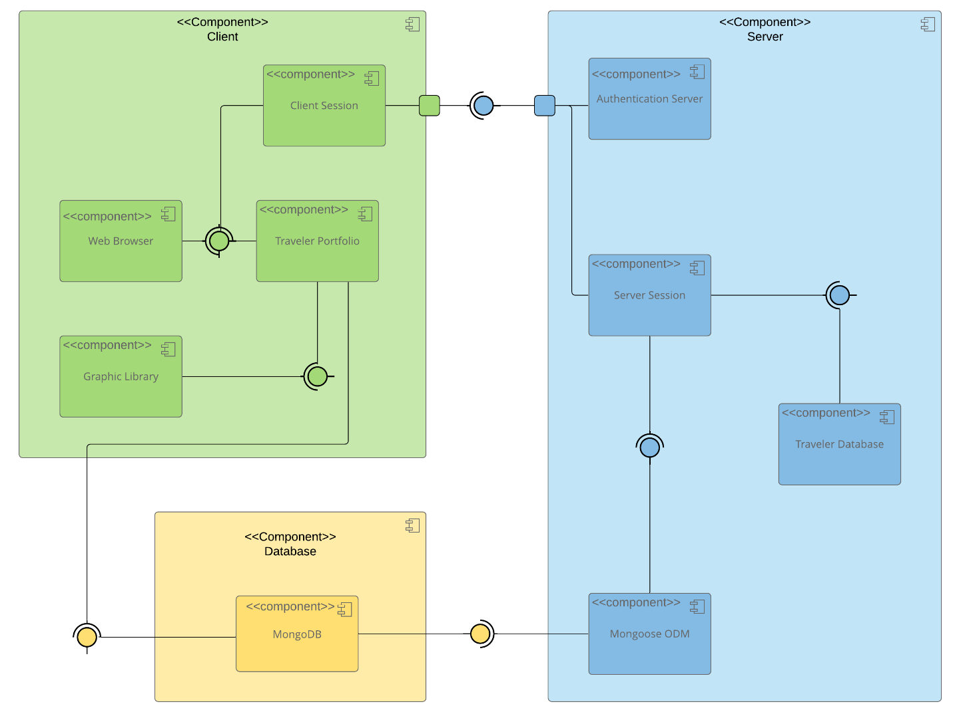

A text version of the component diagram is available: CS 465 Full Stack Component Diagram Text Version.

The component diagram provided in the Software Design Document divides the Travlr Getaways system into three major areas: the Client, Server, and Database. On the client side, the diagram identifies components including the Web Browser, Travlr Portfolio, Client Session, and Graphic Library. On the server side, it identifies the Authorization Server, Server Session, Travlr Database, and Mongoose ODM, while MongoDB is represented within the database component. This separation reflects a layered approach in which users interact with client-side components while the server manages application processing and communication with stored data.

The server acts as the connection between the client-facing portions of Travlr Getaways and its database. Mongoose ODM provides a schema-based approach for modeling application data and includes functionality for validation, queries, and other database operations (Mongoose, n.d.). MongoDB provides persistent data storage, while Node.js and Express support the server-side portion of the MEAN architecture. Angular will provide the interactive administrator SPA on the client side. In a MEAN application these technologies work together across the presentation, application, and database layers rather than placing all functionality within a single component (MongoDB, n.d.). This separation helps organize the Travlr Getaways application and provides a structure that can be maintained as additional functionality is developed.

Sequence Diagram

<Illustrate the flow of logic in a web application by completing a sequence diagram. Insert an image of the sequence diagram here.>

<Describe the flow of logic in the web application based on the sequence diagram. Be sure to describe the interactions between the layers, or tiers, of the full stack application. It will be helpful to include significant processes such as Sign In, Trips, and Admin interactions when referring to the sequence diagram.>

Class Diagram

<Illustrate the JavaScript classes of the web application by completing a class diagram for the web application. Insert an image of the class diagram here.>
<Describe the JavaScript classes of the web application based on the class diagram.>

API Endpoints

<Exposing RESTful endpoints is a design approach to enable an application to participate in a larger ecosystem. Document each endpoint in the table below, including the HTTP method, purpose, URL, and notes.>

Method | Purpose | URL | Notes
GET | <Retrieve list of things> | </api/things> | <Returns all active things>
GET | <Retrieve single thing> | </api/things/:thingId> | <Returns single thing instance, identified by the thing ID passed on the request URL>

The User Interface

<Insert screenshots from the development of the SPA development to show the following: (1) a unique trip, added by you, (2) the Edit screen, and (3) the Update screen.>

<Summarize the Angular project structure and how it compares to the Express project structure. Be sure to describe the rich functionality provided by the SPA compared to a simple web application interaction. Describe the process of testing to make sure the SPA is working with the API to GET and PUT data in the database.>

References

MongoDB. (n.d.). Integrate MongoDB with Angular. http://www.mongodb.com/docs/drivers/node-frameworks/angular/

Mongoose. (n.d.). Schemas. https://mongoosejs.com/docs/guide.html

